4.1 The parameters of the laptop.

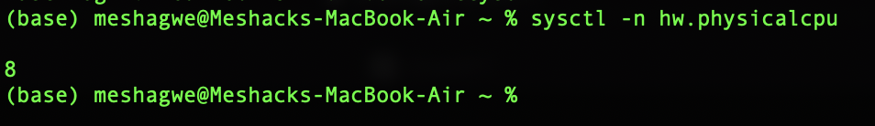Number of processor cores

Clock frequencyScreenshot 2024-03-02 at 14.32.05.png

Number and types of interfaces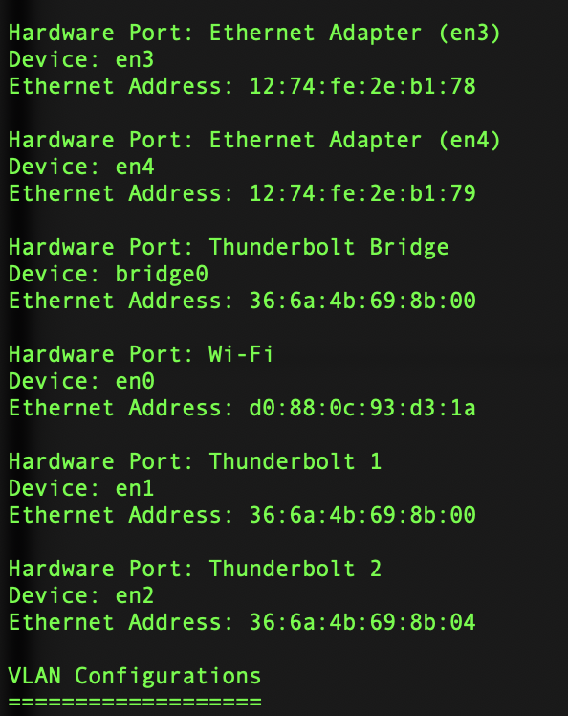

**MOBILE PHONE:**

Mobile Redmi 10C

Cores 8

Clock frequency 2.40 Ghz

Number and types of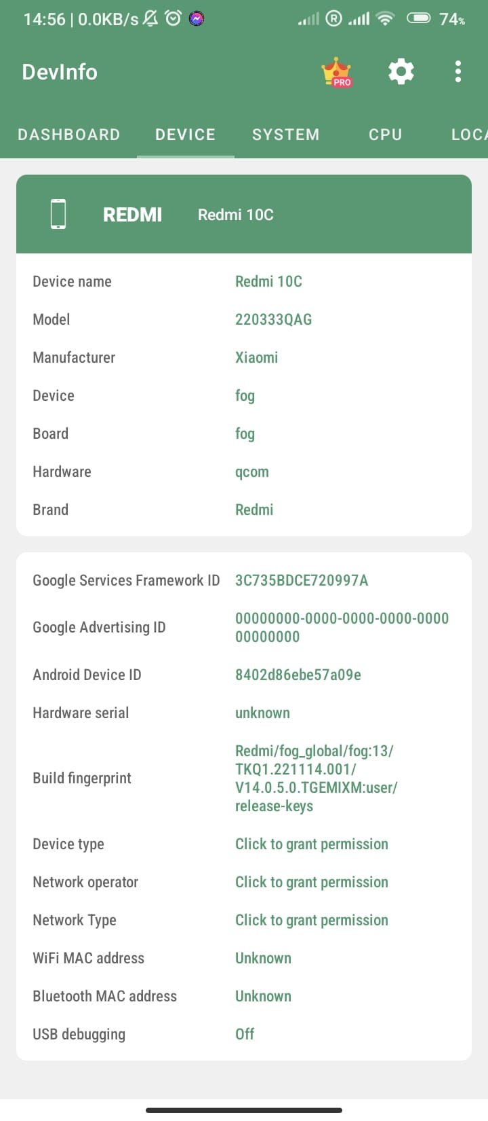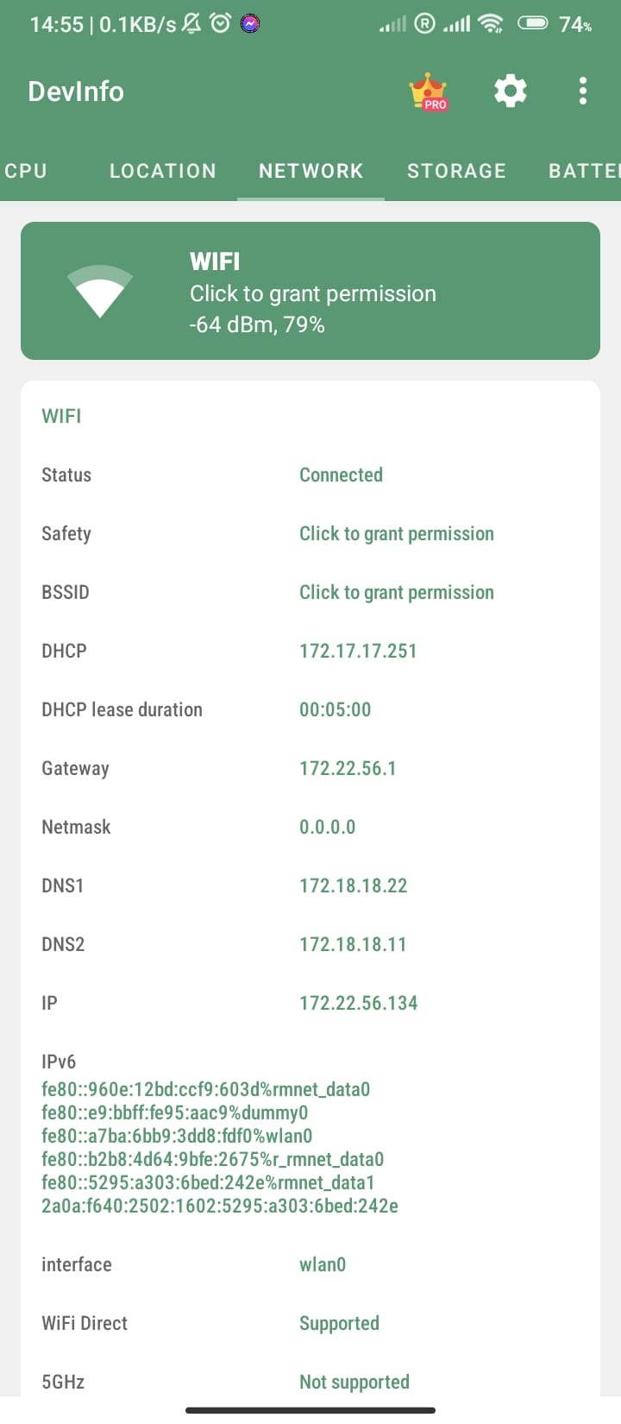 interfaces

4.2

Operating system

type

Version number: 13.5.2

Number of running processes:

CPU loadScreenshot 2024-03-02 at 15.10.10.png

MOBILE PHONE

Mobile Redmi 10C

Type: Android

Version: Android 13

Running processes: Cover 1545 MB of RAM

CPU Load: 1545 MB = 43%

4.3

Optical cables used in practice can be arranged in increasing order according to their size as follows:

1. Single-Mode Fiber(SMF):

Single-mode fibers have a small core diameter down the fiber with only one mode of propagation, allowing for longer distances and higher bandwidth.

2. Multimode Fiber (MMF):

Multimode fibers have a larger core diameter (commonly 50 or 62.5 mm)

They allow multiple modes of light to travel through the fiber simultaneously.

3. Plastic Optical Fiber (POF):

POFs have a larger core diameter (typically 1mm or more) compared to glass fibers.

4. Glass-Core Plastic Clad Fiber (GC-PCF):

GC-PCF is a type of optical fiber with a glass core and a plastic cladding.

4.4 Create a graph where the x-axis represents the number of files (*n*), and the y-axis represents the transfer speed. Plot the data points and overlay the proposed function

Graphical Justification.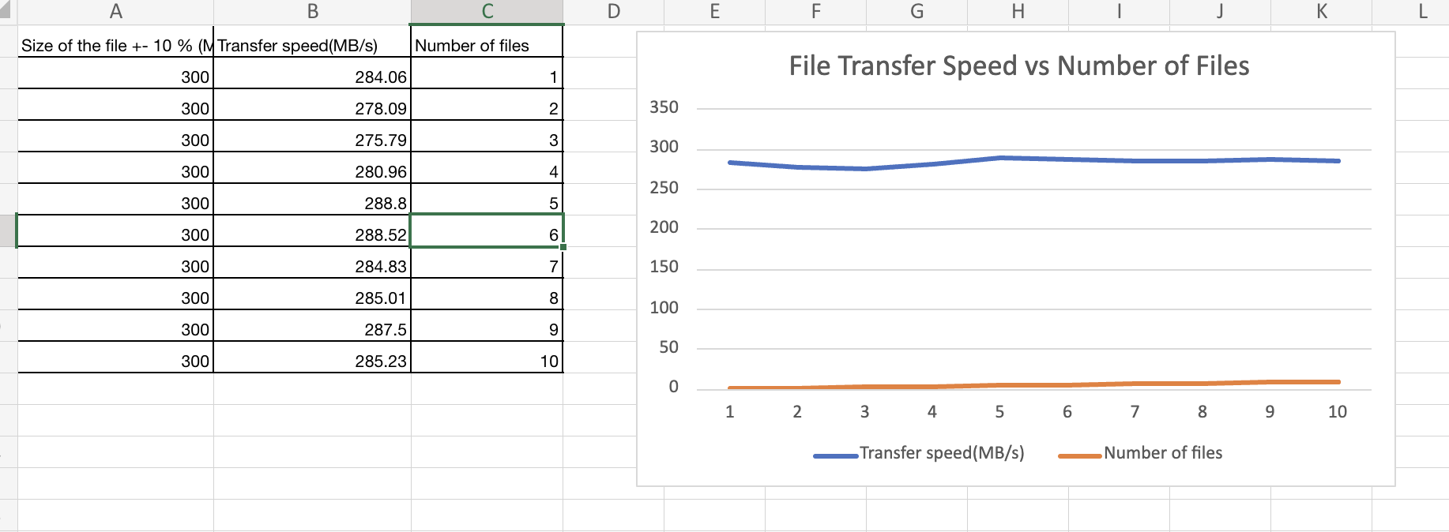

From the experiment I conducted on my MacBook, file transfer is not affected by the number of files. The transfer is generally the same for files of the same size.

4.5

1. How will the file transfer speed of this file size L = 1 MB +/- 10% between the PC and the MS Teams storage depend on the number of files (n)? The equation of the bandwidth is [MB/s] = f2(n). Graphical justification of the data.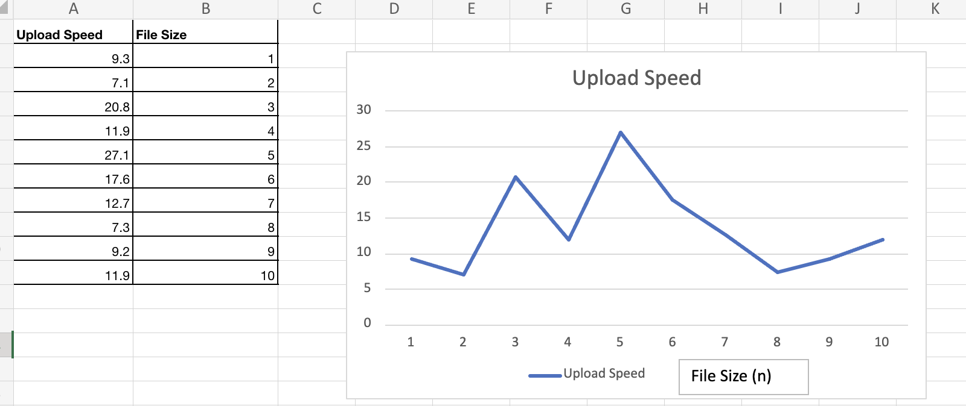

B) The upload speed is independent of the file size.